PROGRAM 2 EXP 1a

import pandas as pd

import matplotlib.pyplot as plt

role=['Data Analyst','Data Engineer','Data Scientist']

count=['250','300','400']

fig=plt.figure(figsize=(10,7))

plt.pie(count,labels=role)

#plt.bar(role,count,color='green')

plt.title('Distribution of various data Science Roles')

plt.xlabel('various roles in data science')

plt.ylabel('count on various roles')

plt.show()

OUTPUT:

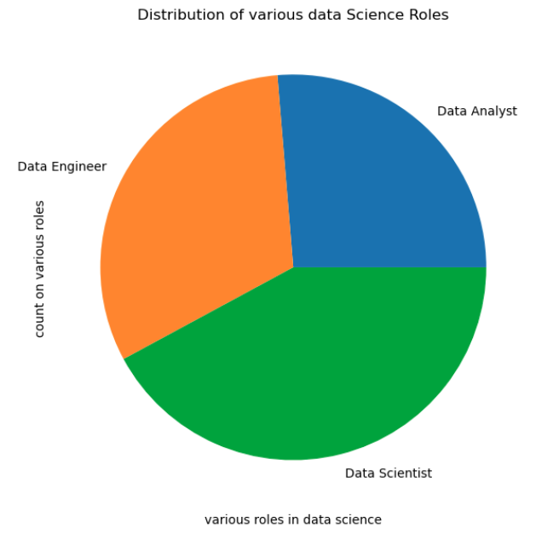

PROGRAM 2 EXP 1b

import pandas as pd

import matplotlib.pyplot as plt

role=['Data Analyst','Data Engineer','Data Scientist']

count=['250','300','400']

fig=plt.figure(figsize=(10,7))

#plt.pie(count,labels=role)

plt.bar(role,count,color='green')

plt.title('Distribution of various data Science Roles')

plt.xlabel('various roles in data science')

plt.ylabel('count on various roles')

plt.show()

OUTPUT:

